Zephyr I.S.D.

Dyslexia & Related Disorders Program Handbook & Guidelines
Update 2021

Table of Contents
- Definition of Dyslexia & Dysgraphia 2-4
- Screening 5-10
Fig 2.5 Universal Screening & Data Review for 11
Reading Risk Chart
- Procedures for the Evaluation & Identification of Students 12-25
With Dyslexia
Figure 3.8 Pathways to the Identification and Provisions of 21-22
Instruction for Students with Dyslexia
- Instruction for Students with Dyslexia & Related Disorders 25-29
- Dysgraphia 29-40
- Instructional Accommodations for Students with Dyslexia 40-41
- Instructional Accommodations for Students with Dysgraphia 41-43
- Timeline 43
- Student Monitoring and Dyslexia Program Exit Criteria 43-44
- Contacts for Dyslexia & Related Disorders 45

Definition of Dyslexia and Dysgraphia
As defined in Texas Education Code §38.003 http://www.statutes.legis.state.tx.us/DOcs/ED/htm/ED.38.htm#38.003

- “Dyslexia” means a disorder of constitutional origin manifested by a difficulty in learning to read, write, or spell, despite conventional instruction, adequate intelligence, and sociocultural opportunity. “Related disorders” include disorders similar to or related to dyslexia, such as developmental auditory imperception, dysphasia, specific developmental dyslexia, developmental dysgraphia, and developmental spelling disability.

- “Related disorders” includes disorders similar to or related to dyslexia such as developmental auditory imperception, dysphasia, specific developmental dyslexia, developmental dysgraphia, and developmental spelling disability.

- “Dysgraphia” is best defined as a neurodevelopmental disorder manifested by illegible and/or inefficient handwriting due to difficulty with letter formation. This difficulty is the result of deficits in graphomotor function (hand movements used for writing) and/or storing and retrieving orthographic codes (letter forms) (Berninger, 2015). Secondary consequences may include problems with spelling and written expression. It is not solely due to lack of instruction and is not associated with other developmental or neurological conditions that involve motor impairment. (p. 59)

Students identified as having dyslexia typically experience primary difficulties in phonological awareness and manipulation, single word reading, reading fluency, and spelling. Consequences may include difficulties in phonological awareness, are unexpected for the student’s age and educational level, and are not primarily the result of language difference factors. Additionally, there is often a family history of similar difficulties.

The following are the primary reading/spelling characteristics of dyslexia:
- Difficulty reading words in isolation
- Difficulty accurately decoding unfamiliar words
- Difficulty with oral reading (slow, inaccurate, or labored without prosody)
- Difficulty spelling

***It is important to note that individuals demonstrate differences in degree of impairment and may not exhibit all the characteristics listed above.

Evidence-based Core Reading Instruction (Tier 1)
House bill 3, passed by the 86th Legislature, requires each school district and open-enrollment charter school to provide for the use of a phonics curriculum that uses systematic direct instruction in kindergarten through third grade to ensure all students obtain necessary early literacy skills. Districts and charter schools must ensure that all kindergarten, first, second, and third grade teachers attend a teacher literacy achievement academy to increase teacher

knowledge and implementation of the science of teaching reading. Additionally, districts and charter schools must certify to the agency that they prioritize placement of highly effective teachers in kindergarten through second grade and have integrated reading instruments used to diagnose reading development and comprehension to support each student in prekindergarten through third grade. The Dyslexia Handbook: Procedures Concerning Dyslexia and Related Disorders 2021 Update assumes that all students have received strong systematic reading instruction in Tier 1.

Common Risk Factors Associated with Dyslexia
If the following behaviors are unexpected for an individual’s age, educational level, or cognitive abilities, they may be risk factors associated with dyslexia. A student with dyslexia usually exhibits several of these behaviors that persist over time and interfere with his/her learning. A family history of dyslexia may be present; in fact, recent studies reveal that the whole spectrum of reading disabilities is strongly determined by genetic predispositions (inherited aptitudes) (Olson, Keenan, Byrne, & Samuelsson, 2014).
The following characteristics identify risk factors associated with dyslexia at different stages or grade levels.

Preschool
- Delay in learning to talk
- Difficulty with rhyming
- Difficulty pronouncing words (e.g., “pusgetti” for “spaghetti,” “mawn lower” for “lawn mower”)
- Poor auditory memory for nursery rhymes and chants
- Difficulty adding new vocabulary words
- Inability to recall the right word (word retrieval)
- Trouble learning and naming letters and numbers and remembering the letters in his/ her name
- Aversion to print (e.g., doesn’t enjoy following along if a book is read aloud)

Kindergarten and First Grade
- Difficulty breaking words into smaller parts, or syllables (e.g., “baseball” can be pulled apart into “base” “ball” or “napkin” can be pulled apart into “nap” “kin”)
- Difficulty identifying and manipulating sounds in syllables (e.g., “man” sounded out as /m/ /ă/
/n/)
- Difficulty remembering the names of letters and recalling their corresponding sounds
- Difficulty decoding single words (reading single words in isolation)
- Difficulty spelling words the way they sound (phonetically) or remembering letter sequences in very common words seen often in print (e.g., “sed” for “said”)

Second Grade and Third Grade
Many of the previously described behaviors remain problematic along with the following:
- Difficulty recognizing common sight words (e.g., “to,” “said,” “been”)
- Difficulty decoding single words

- Difficulty recalling the correct sounds for letters and letter patterns in reading
- Difficulty connecting speech sounds with appropriate letter or letter combinations and omitting letters in words for spelling (e.g., “after” spelled “eftr”)
- Difficulty reading fluently (e.g., reading is slow, inaccurate, and/or without expression)
- Difficulty decoding unfamiliar words in sentences using knowledge of phonics
- Reliance on picture clues, story theme, or guessing at words
- Difficulty with written expression

Fourth Grade through Sixth Grade
Many of the previously described behaviors remain problematic along with the following:
- Difficulty reading aloud (e.g., fear of reading aloud in front of classmates)
- Avoidance of reading (particularly for pleasure)
- Difficulty reading fluently (e.g., reading is slow, inaccurate, and/or without expression)
- Difficulty decoding unfamiliar words in sentences using knowledge of phonics
- Acquisition of less vocabulary due to reduced independent reading
- Use of less complicated words in writing that are easier to spell than more appropriate words (e.g., “big” instead of “enormous”)
- Reliance on listening rather than reading for comprehension

Middle School and High School
Many of the previously described behaviors remain problematic along with the following:
- Difficulty with the volume of reading and written work
- Frustration with the amount of time required and energy expended for reading
- Difficulty reading fluently (e.g., reading is slow, inaccurate, and/or without expression)
- Difficulty decoding unfamiliar words in sentences using knowledge of phonics
- Difficulty with written assignments • Tendency to avoid reading (particularly for pleasure)
- Difficulty learning a foreign language

Postsecondary
Some students will not be identified as having dyslexia prior to entering college. The early years of reading difficulties evolve into slow, labored reading fluency. Many students will experience extreme frustration and fatigue due to the increasing demands of reading as the result of dyslexia. In making a diagnosis for dyslexia, a student’s reading history, familial/genetic predisposition, and assessment history are critical. Many of the previously described behaviors may remain problematic along with the following:
- Difficulty pronouncing names of people and places or parts of words
- Difficulty remembering names of people and places
- Difficulty with word retrieval
- Difficulty with spoken vocabulary
- Difficulty completing the reading demands for multiple course requirements
- Difficulty with note taking
- Difficulty with written production
- Difficulty remembering sequences (e.g., mathematical and/or scientific formulas)

Screening
Dyslexia screening is a tool for identifying children who are at risk for this learning disability, particularly in preschool, kindergarten, or first grade. This means that the screening does not “diagnose” dyslexia. Rather, it identifies “predictor variables” that raise red flags, so parents and teachers can intervene early and effectively.
—Richard Selznick, Dyslexia Screening: Essential Concepts for Schools and Parents, 2015

Part A: Universal Screening and State and Federal Requirements The Importance of Early Screening

If the persistent achievement gap between dyslexic and typical readers is to be narrowed, or even closed, reading interventions must be implemented early, when children are still developing the basic foundation for reading acquisition. The persistent achievement gap poses serious consequences for dyslexic readers, including lower rates of high school graduation, higher levels of unemployment, and lower earnings because of lowered college attainment. Implementing effective reading programs early, even in preschool and kindergarten, offers the potential to reduce and perhaps even close the achievement gap between dyslexic and typical readers and bring their trajectories closer over time.
—Ferrer, et al., Achievement Gap in Reading Is Present as Early as First Grade and Persists through Adolescence, 2015
The early identification of students with dyslexia along with corresponding early intervention programs for these students will have significant implications for their future academic success. In the book Straight Talk about Reading, Hall and Moats (1999) state the following:

- Early identification is critical because the earlier the intervention, the easier it is to remediate.
- Inexpensive screening measures identify at-risk children in mid-kindergarten with 85 percent accuracy.
- If intervention is not provided before the age of eight, the probability of reading difficulties continuing into high school is 75 percent (pp. 279–280).

In 2017, the 85th Texas Legislature passed House Bill (HB) 1886, amending Texas Education Code (TEC) §38.003, Screening and Treatment for Dyslexia, to require that all kindergarten and first-grade public school students be screened for dyslexia and related disorders. Additionally, the law requires that all students beyond first grade be screened or tested as appropriate.

A related state law adds an additional layer to screening requirements for public school students. Texas Education Code §28.006, Reading Diagnosis, requires each school district to administer to students in kindergarten, first grade, and second grade a reading instrument to diagnose student reading development and comprehension. This law also requires school districts to administer a reading instrument at the beginning of seventh grade to students who did not demonstrate reading proficiency on the sixth-grade state reading assessment. The law requires each school district to administer to kindergarten students a reading instrument adopted by the commissioner.

The commissioner must adopt a list of reading instruments that a school district may use to diagnose student reading development and comprehension. Districts are permitted to use reading instruments other than those adopted by the commissioner for first, second, and seventh grades only when a district-level committee adopts these additional instruments. Texas Education Code
§28.006(d) requires each district to report the results of these reading instruments to the district’s board of trustees, TEA, and the parent or guardian of each student. Further, a school district is required to notify the parent or guardian of each student in kindergarten, first grade, or second grade who is determined to be at risk for dyslexia or other reading difficulties based on the results of the reading instruments. In accordance with TEC §28.006(g), an accelerated reading instruction program must be provided to these students.

In accordance with screening and early reading indicators, ISD will screen at appropriate times in grades K and 1. Additionally, ISD will administer early reading indicators at K, 1, 2, and 7. The provisions offered to students who are reported to be at risk for dyslexia or other reading difficulties should align to the requirements of the Elementary and Secondary Education Act (ESEA) legislation. ISD will implement reading programs using scientifically based reading research to ensure district wide success. It is important to note that TEC §38.003 applies only to the screening of kindergarten and first-grade students for dyslexia and related disorders, whereas TEC §28.006 addresses general reading diagnoses for students in kindergarten and grades 1, 2, and 7. Districts that decide to use one instrument to meet the requirements of both the dyslexia screening and the early reading diagnosis for kindergarten and grade 1 must also continue to administer reading instruments to all second-grade students and to students in grade 7 who did not demonstrate proficiency on the state reading assessment for sixth grade.

Federal Requirements - Child Find

In addition to state and local requirements to screen and identify students who may be at risk for dyslexia, there are also overarching federal laws and regulations to identify students with disabilities, commonly referred to as Child Find. Child Find is a provision of the Individuals with Disabilities Act (IDEA), a federal law that requires that state to have policies and procedures in place to ensure that every student in the state who needs special education and related services is located, identified, and evaluated. The purpose of the IDEA is to ensure that students with disabilities are offered a free and appropriate public education (20 U.S.C.
§1400(d); 34 C.F.R §300.1). Because a student suspected of having dyslexia may be a student with a disability under IDEA, the Child Find mandate includes these students. Therefore, when referring and evaluating students suspected of having dyslexia, LEAs must follow procedures for conducting a full individual and initial evaluation (FIIE) under the IDEA.

Another federal law that applies to students with disabilities in public school is Section 504 of the Rehabilitation Act of 1973, commonly referred to as Section 504. Under Section 504, public schools must annually attempt to identify and locate every qualified student with a disability residing in its jurisdiction and notify them and/or their parents of the requirements of Section 504.

Universal Screener

Under the Equal Education Opportunity Act (EEOA), ISD ensures that all students are given equal access to educational services regardless of race, color, sex, religion, or national origin. Therefore, research-based interventions are to be provided to all students experiencing difficulties in reading, including English language learners (ELL), regardless of their proficiency in English.
Timing of Screening
Texas Education Code §38.003 mandates that kindergarten students be screened at the end of the school year. In scheduling the kindergarten screener, districts and charter schools should consider the questions in Figure 2.1 below.

Figure 2.1. Considerations for Local Scheduling of Dyslexia Screening
- Has adequate time for instruction been provided during the school year?
- Has adequate time been provided to compile data prior to the end of the school year?
- How will the timing of the administration of the screener fit in with the timing of other required assessments?
- Has sufficient time been provided to inform parents in writing of the results of the reading instrument and whether the student is at risk for dyslexia or other reading difficulties?
- Has adequate time been provided for educators to offer appropriate interventions to the student?
- Has sufficient time been provided for decision making regarding next steps in the screening process?

Texas Education Code §38.003 does not explicitly state when first grade students must be screened. The SBOE, through approval of the rule which requires adherence to this handbook (TAC §74.28), has determined that students in first grade must be screened no later than the middle of the school year. Screening of first-grade students can begin anytime in the fall as the teacher deems appropriate. Grade 1 screening must conclude no later than January 31 of each year. Kindergarten dyslexia screening must conclude no later than the end of the school year.

Screening Instruments

While screening instruments can measure the skills and abilities of students at different grade levels, this section is dedicated to a discussion of instruments that may meet the dyslexia screening requirement for kindergarten and first grade students. As previously mentioned, at the time of the update to this handbook it was determined there are no grade-level appropriate screening instruments for dysgraphia and the other identified related disorders. As a result, the focus of this section is on screening instruments for dyslexia and reading difficulties.
It is important that screening instruments be accurate and comprehensive; however, they need not be as comprehensive as an extensive individualized evaluation. With

this in mind, various types of instruments that meet the criteria below could be used to screen for dyslexia.

In developing the criteria for the kindergarten and grade 1 screening instruments for dyslexia and other reading difficulties, it was important to differentiate between the skills and behaviors appropriate at each grade level. Additionally, with a sizable English Learner (EL) population in Texas, it was essential that Spanish language screening instruments be addressed. Therefore, criteria for both English and Spanish speakers are included.

Figure 2.2. Criteria for English and Spanish Screening Instruments
Kindergarten | First Grade
- Letter Naming Fluency  - Phonological Awareness | - Word Reading Accuracy or Fluency  - Phonological Awareness

A list of behaviors that may be observed during the administration of the screening and which should be documented are included in Figure 2.3 below.
- Lack of automaticity
- Difficulty sounding out words left to right
- Guessing
- Self-correcting
- Inability to focus on reading
- Avoidance behavior
Figure 2.3. Student Behaviors Observed During Screening

ISD will utilize , an approved screening tool, for Kindergarten and First Grade dyslexia screeners.

Part B: Universal Screening and State and Federal Requirements Screener Results

In general, students scoring below the publisher-determined cut point are considered “at risk” for dyslexia, while those who score above the cut point are considered “not at risk” for dyslexia.
However, it is important to realize that risk falls on a continuum and there will always be false positives (students who screen at risk when they are not) and false negatives (students who screen not at risk when they are). Consequently, continual progress monitoring and an ongoing review of data is important. Any student may be referred for a full individual and initial evaluation under IDEA at any time, regardless of the results of the screening instrument.

Students falling well below the cut point have a much higher probability of being at risk for dyslexia while students scoring well above the cut point have lower probability of being at risk for dyslexia. The decision for what to do next is easiest for students whose scores fall at the extreme ends of the continuum.

Students falling well above the cut point can be considered at low risk for dyslexia and are much less likely to need additional intervention or evaluation. Students scoring far below the cut point should be considered at high risk for dyslexia.

For students who are identified as at risk for dyslexia, the school should provide targeted intervention provided by the appropriate staff as determined by the district or charter school. The district or school should also continue the data collection and evaluation process outlined in Chapter III, Procedures for the Evaluation and Identification of Students with Dyslexia. It is important to note that the use of a tiered intervention process, such as Response to Intervention or RTI, must not be used to delay or deny an evaluation for dyslexia, especially when parent or teacher observations reveal the common characteristics of dyslexia.

For students who score close to the cut point, more information will be needed to make an informed decision regarding referral for evaluation, implementation of targeted interventions with progress monitoring, or continuation of core instruction only. Data gathering will provide this additional information.
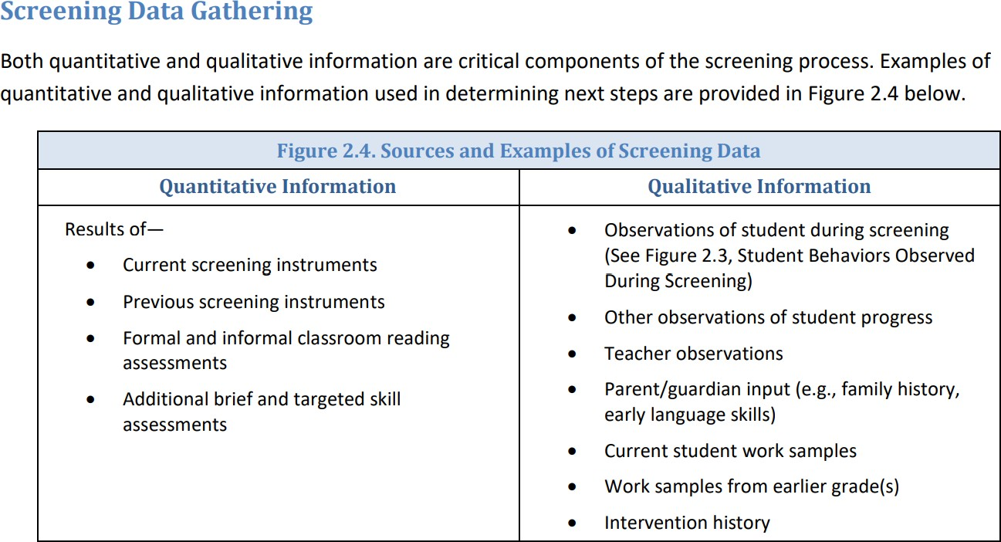

For students who fall close to the predetermined cut points, implementation of short-term, targeted intervention with regular progress monitoring is one way to determine if additional evaluation is needed.
It is important to remember that at any point in the data review process a referral for a FIIE under the IDEA may be initiated. Parents also have the right to request a FIIE at any time. Regardless

of the process in place for screening and data review, whenever accumulated data indicate that a student continues to struggle with one or more of the components of reading, despite the provision of adequate instruction and intervention, the student must be referred for a full individual and initial evaluation under the IDEA.

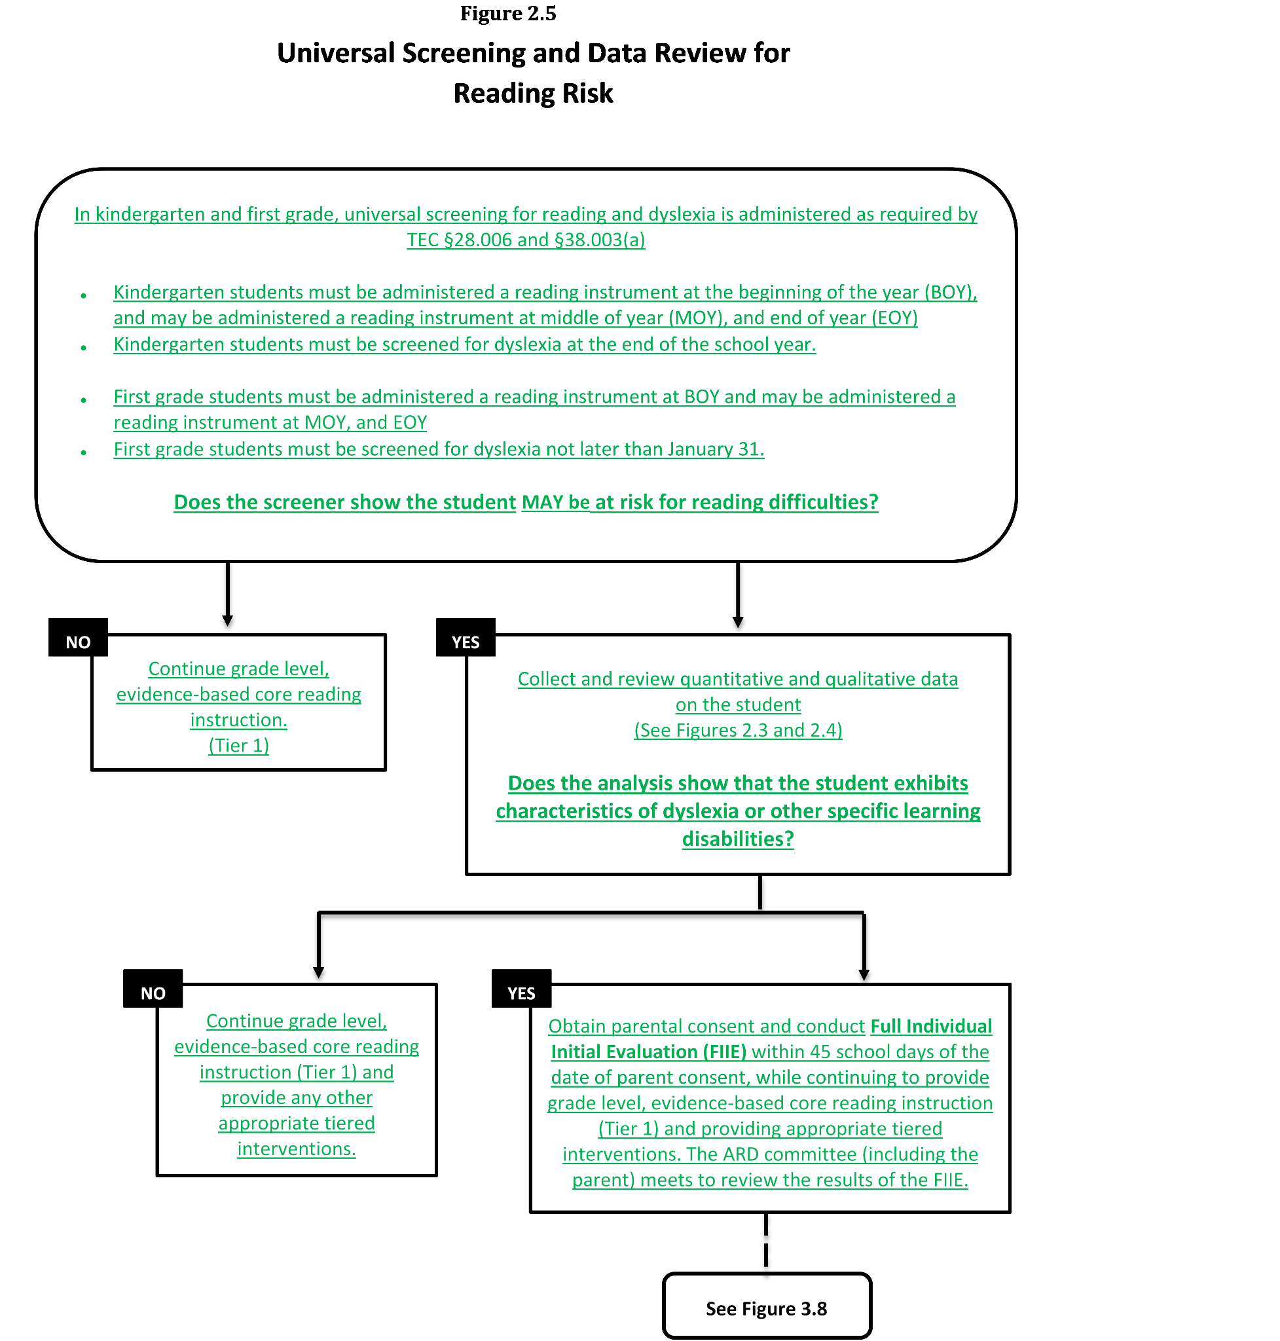

Procedures for the Evaluation and Identification of Students with Dyslexia

Science has moved forward at a rapid pace so that we now possess the data to reliably define dyslexia, to know its prevalence, its cognitive basis, its symptoms and remarkably, where it lives in the brain and evidence-based interventions which can turn a sad, struggling child into not only a good reader, but one who sees herself as a student with self-esteem and a fulfilling future.
—Shaywitz, S.E. Testimony Before the Committee on Science, Space, and Technology, U.S. House of Representatives, 2014

The evaluation and identification process for dyslexia can be multifaceted. The process involves both state and federal requirements that must be followed. The evaluation and identification process for students suspected of having dyslexia is guided by the Individuals with Disabilities Act (IDEA).

Data-Driven Meeting of Knowledgeable Persons
A team of persons with knowledge of the student, instructional practices, and instructional options meets to discuss data collected, including data obtained during kindergarten and/or first grade screening, and the implications of that data. These individuals include, but are not limited to, the classroom teacher, administrator, dyslexia specialist, and/or interventionist. This team may also include the parents and/or a diagnostician familiar with testing and interpreting evaluation results. This team may have different names in
different districts and/or campuses. For example, the team may be called a student success team, student support team, student intervention team, or even something else. This team of knowledgeable persons is not an Admission, Review, and Dismissal (ARD) committee or a Section 504 committee, although many of these individuals may be on a future committee if the student is referred for an evaluation.

When the Data Does Not Lead to Suspicion of a Disability, Including Dyslexia or a Related Disorder
If the team determines that the data does not give the members reason to suspect that a student has dyslexia, a related disorder, or other disability, the team may decide to provide the student with additional support in the classroom or through the RTI/MTSS process. The student should continue to receive grade level, evidence-based core reading instruction, (Tier 1) and any other appropriate tiered interventions. However, the student is not referred for an evaluation at this time.

When the Data Lead to a Suspicion of a Disability, Including Dyslexia or a Related Disorder
If the team suspects that the student has dyslexia, a related disorder, or another disability included within the IDEA, the team must refer the student for [the team should consider the type of instruction that would best meet the student’s needs] a full individual and initial evaluation (FIIE). In most cases, an FIIE under the IDEA must be completed within 45-school days from the time a district or charter school receives parental consent.

Parents/guardians always have the right to request a referral for a dyslexia evaluation at any time. Once a parent request has been made, the school district is obligated to review the student’s data history (both formal and informal data) to determine whether there is reason to suspect the student has a disability. If a disability is suspected, the student needs to be evaluated following the guidelines outlined in this chapter. Under the IDEA, if the school rejects the request to evaluate, it must give parents prior written notice of its refusal to evaluate, including an explanation of why the school refuses to conduct an FIIE, the information that was used as the basis for the decision, and a copy of the Notice of Procedural Safeguards. Should the parent believe that their child is eligible for Section 504 aids, accommodations, and services the parent may request an evaluation under Section 504.

Procedures of Evaluation
As discussed above, Child Find is a provision in the federal Individuals with Disabilities Act (IDEA), a federal law that requires the state to have policies in place to ensure that every student in the state who needs special education and related services is located, identified, and evaluated. The purpose of the IDEA is to ensure that students with disabilities are offered a free and appropriate public education (20 U.S.C. §1400(d); 34 C.F.R. §300.1). Because a student suspected of having dyslexia may be a student with a disability under the IDEA, the Child Find mandate includes these students. Therefore, when referring and evaluating students suspected of having dyslexia, LEAs must follow procedures for conducting a full individual and initial evaluation (FIIE) under the IDEA. For detailed information regarding Child Find see https://tea.texas.gov/sites/default/files/Technical%20Assistance%20-
%20Child%20Find%20and%20Evaluation%20-%20June%202020%20Revised%28v5%29.pdf

If at any time (from kindergarten through grade 12), a student continues to struggle with one or more components of reading, ISD will collect additional information about the student.
ISD teachers/administrators/staff may make a dyslexia referral any time they suspect a student may be demonstrating characteristics of dyslexia. This may be done through the regularly scheduled campus Student Success Team meetings or by contacting the campus dyslexia teacher. The needs of ISD’s students are our foremost priority. A parent referral can also be made at any time by contacting ISD in writing.

Data Gathering:

When evaluating a student for dyslexia, the collection of various data, as indicated in Figure 3.2 below, will provide information regarding factors that may be contributing to or primary to the student’s struggles with reading and spelling.

Cumulative Data
Information will be used to evaluate the student’s academic progress and determine what actions are needed to ensure the student’s improved academic performance. This information should

include data that demonstrates the student was provided appropriate instruction and data-based documentation of repeated assessments of achievement at reasonable intervals (progress monitoring), reflecting formal assessment of student progress during instruction. Additional information to be considered includes the results from some or all of the following:

Figure 3.2 Sources and Examples of Cumulative Data
- Vision Screening
- Hearing Screening
- Teacher reports of classroom concerns
- Classroom reading assessments
- Accommodations or interventions provided
- Academic progress reports (report cards)
- Gifted/talented assessment
- Samples of schoolwork
- Parent conference notes
- Results of K-1 universal screening as required TEC §38.003
- K-2 reading instrument results as required in TEC §28.006(English and native language, if possible)
- 7th grade reading instrument results as required in TEC §28.006
- State student assessment program results as described in TEC §39.002
- Observations of instruction provided to the student
- Previous evaluations
- Outside evaluations
- Speech and language assessment
- School attendance
- Curriculum-based assessment measures
- Instructional strategies provided and student’s response to the instruction
- Screening data
- Parent survey

Data will be collected that supports the student has received conventional (appropriate) instruction and that the difficulties are not primarily the result of sociocultural factors which include language differences, irregular attendance, or lack of experiential background.

ISD may recommend assessment for dyslexia if the student demonstrates the following:
  - Poor performance in one or more areas of reading and/or the related area of spelling that is unexpected for the student’s age/grade
  - Characteristics and risk factors of dyslexia

Primary Reading/Spelling Characteristics of Dyslexia:
  - Difficulty reading words in isolation
  - Difficulty accurately decoding unfamiliar words
  - Difficulty with oral reading (slow, inaccurate, or labored)
  - Difficulty spelling

It is important to note that students demonstrate differences in degree of impairment. The reading/spelling characteristics are most often associated with the following:
  - Segmenting, blending, and manipulating sounds in words (phonemic awareness)
  - Learning the names of letters and their associated sounds
  - Holding information about sounds and words in memory (phonological memory)
  - Rapid recalling the name of familiar objects, colors, or letters of the alphabet (rapid naming)
Consequences of dyslexia may include the following:
  - Variable difficulty with aspects of reading comprehension
  - Variable difficulty with aspects of written language
  - Limited vocabulary growth due to reduced reading experiences

Students enrolling in ISD shall be assessed for dyslexia and related disorders at appropriate times (TEC §38.003(a)). The appropriate time depends upon multiple factors including the student’s reading performance, reading difficulties, poor response to supplemental, scientifically based reading instruction, teachers’ input, and parents’ or guardians’ input.
Additionally, the appropriate time for assessing is early in a student’s school career (19 TAC
§74.28), the earlier the better. While earlier is better, students will be recommended for assessment for dyslexia even if the reading difficulties appear later in a student’s school career.

When formal assessment is recommended, completes the evaluation process as outlined under IDEA.

- Notify parents or guardians of proposal to assess student for dyslexia.
- Inform parents or guardians of their rights.
- Obtain parent or guardian permission to assess the student for dyslexia.
- Assess student, being sure that individuals/professionals who administer assessments have training in the evaluation of students for dyslexia and related disorders (19 TAC §74.28).

In compliance with §504 and IDEA 2004, test instruments, and other evaluation materials must meet the following criteria:
  - Be validated for the specific purpose for which the tests, assessments, and other evaluation materials are used

  - Include material tailored to assess specific areas of educational need and not merely materials that are designed to provide a single general intelligence quotient
  - Be selected and administered so as to ensure that, when a test is given to a student with impaired sensory, manual, or speaking skills, the test results accurately reflect the student’s aptitude or achievement level, or whatever other factor the test purports to measure, rather than reflecting the student’s impaired sensory, manual, or speaking skills
  - Be selected and administered in a manner that is not racially or culturally discriminatory
  - Include multiple measures of a student’s reading abilities such as informal assessment information (e.g., anecdotal records, district universal screenings, progress monitoring data, criterion referenced assessments, results of informal reading inventories, classroom observations)
  - Be administered by trained personnel and in conformance with the instructions provided by the producer of the evaluation materials
  - Be used for the purpose for which the assessment or measures are valid or reliable
  - Be provided and administered in the student’s native language or other mode of communication and in the form most likely to yield accurate information regarding what the child can do academically, developmentally, and functionally, unless it is clearly not feasible to provide or administer

Domains to Assess
ISD administers measures that are related to the student’s educational needs. Depending upon the student’s age and stage of reading development, the following are the areas related to reading that should be assessed:

Academic Skills
- Letter knowledge (name and associated sound)
- Reading words in isolation
- Reading fluency (both rate and accuracy are measured)
- Reading comprehension
- Decoding unfamiliar words accurately
- Spelling

Cognitive processes that underlie the reading difficulties
- Phonological/phonemic awareness (Difficulties in phonological and phonemic awareness are typically seen in students with dyslexia and impact a student’s ability to learn letters and the sounds associated with letters and letter combinations, learn the alphabetic principle, use the sounds of the letters and letter combinations to decode words and to accurately spell.)
- Rapid naming (Difficulties in rapid naming may or may not be weak, but if deficient, will impact a student’s ability to automatically name letters and read words and to read connected text at an appropriate rate.)
- Orthographic processing (Memory for letter patterns, letter

sequences, and the letters in whole words may be selectively impaired or may coexist with phonological processing weaknesses.)
- Various language processes (Language processes such as morpheme and syntax awareness, memory and retrieval of verbal labels, and the ability to formulate ideas into grammatical sentences, may also be factors affecting reading.)

Based on the student’s academic difficulties and characteristics, additional areas that may be assessed include the following:
- Vocabulary
- Listening comprehension
- Verbal expression
- Written expression
- Handwriting
- Memory for letter or symbol sequences (Orthographic processing)
- Mathematical/calculation reasoning
- Phonological memory
- Verbal working memory
- Processing speed

Language Proficiency:

English Language Learners: This refers to students served in Bilingual and ESL programs as well as students designated Limited English Proficient (LEP) whose parents have denied services.

Much diversity exists among English Language Learners (ELLs). The identification and service delivery process for dyslexia must be in step with the student’s linguistic environment and educational background. Involvement of the Language Proficiency Assessment Committee (LPAC) in the decision-making process is required.
Additional data to be gathered when assessing English Language Learners:
  - Language Proficiency Assessment Committee (LPAC) documentation which includes the following:
  - Home language survey
  - Assessment related to identification for limited English proficiency (oral language proficiency tests and norm-referenced tests)
  - State student assessment data results when available
  - Texas English Language Proficiency system (TELPAS) information (Reading Proficiency Test in English (RPTE))
  - Type of language programming provided and language of instruction
  - Linguistic environment and second-language acquisition development
  - Previous schooling in and outside of the United States

Additional assessment when assessing English Language Learners:
  - Comprehensive oral language proficiency testing should be completed for a dyslexia evaluation due to the importance of the information for consideration in relation to academic challenges, planning the assessment, and interpreting assessment results.

Review and Interpretation of Data and Evaluations

To appropriately understand evaluation data, the ARD committee must interpret test results in light of the student’s educational history, linguistic background, environmental or socioeconomic factors, and any other pertinent factors that affect learning. As part of the evaluation when dyslexia is suspected, in addition to the parent and team of qualified professionals required under IDEA, it is recommended that the multi-disciplinary evaluation team include members who have specific knowledge regarding -
  - The reading process
  - Dyslexia and related disorders, and
  - Dyslexia instruction

A determination must first be made regarding whether a student’s difficulties in the area of reading and spelling reflect a pattern of evidence for the primary characteristics of dyslexia with unexpectedly low performance for the student’s age and educational level in some or all of the following areas:
  - Reading words in isolation
  - Decoding unfamiliar words accurately and automatically
  - Reading fluency for connected text (rate and/or accuracy and/or prosody)
  - Spelling (an isolated difficulty in spelling would not be sufficient to identify dyslexia)

Another factor to consider when interpreting test results is the student’s linguistic background. The nature of the writing system of a language impacts the reading process. Thus, the identification guideposts of dyslexia in languages other than English may differ. For example, decoding in a language with a transparent written language (e.g., Spanish, German) may not be as decisive an indicator of dyslexia as reading rate. A transparent written language has a close letter/sound correspondence (Joshi & Aaron, 2006). Students with dyslexia who have or who are being taught to read and write a transparent language may be able to decode real and nonwords adequately but demonstrate serious difficulties in reading rate with concurrent deficiencies in phonological awareness and rapid automatized naming (RAN).

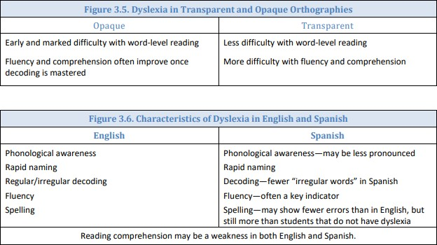

Interpretation:
Test results of English Language Learners (ELL) will be interpreted in light of the student’s: language development (in both English and the student’s native language), educational history, linguistic background, socio economic issues, nature of the writing system, and any other pertinent factors that affect learning.

Dyslexia Identification

If the student’s difficulties are unexpected in relation to other abilities, the ARD committee must then determine if the student has dyslexia. For ELs, an LPAC representative must be included on the ARD committee. The list of questions in Figure 3.7 below must be considered when making a determination regarding dyslexia.

Figure 3.7 Questions to Determine the Identification of Dyslexia
- Do the data show the following characteristics of dyslexia?
  - Difficulty with accurate and/or fluent word reading
  - Poor spelling skills
  - Poor decoding ability
- Do these difficulties (typically) result from a deficit in the phonological component of language?
(Please be mindful that average phonological scores alone do not rule out dyslexia.)
- Are these difficulties unexpected for the student’s age in relation to the student’s other abilities and provision of effective classroom instruction?

If, through the evaluation process, it is established that the student has the condition of dyslexia, as described in Chapter 1, then the student meets the first prong of eligibility under IDEA (identification of condition). In other words, the identification of dyslexia, using the process outlined in this chapter, meets the criterion for the condition of a specific learning disability in basic reading and/or reading fluency. However, the presence of a disability condition alone, is not sufficient to determine if the student is a student with a disability under IDEA. Eligibility under the IDEA consists of both identification of the condition and a corresponding need for specially designed instruction as a result of the disability.
In IDEA, dyslexia is considered one of a variety of etiological foundations for specific learning disability (SLD). Section 34 C.F.R. §300.8(c)(10) states the following:

Specific learning disability means a disorder in one or more of the basic psychological processes involved in understanding or in using language, spoken or written, that may manifest itself in the imperfect ability to listen, think, speak, read, write, spell, or to do mathematical calculations, including conditions such as perceptual disabilities, brain injury, minimal brain dysfunction, dyslexia, and developmental aphasia.

The term SLD does not apply to children who have learning difficulties that are primarily the result of visual, hearing, or motor disabilities; of intellectual disability; of emotional disturbance; or of environmental, cultural, or economic disadvantage.

The IDEA evaluation requirements for SLD eligibility in 34 C.F.R. §300.309(a)(1) specifically designates the following areas for a learning disability: basic reading skills (dyslexia) reading fluency skills, and/or reading comprehension.

If - based on the data - the student is identified with dyslexia, but is not eligible for special education, the student may receive dyslexia instruction and accommodations under Section 504.

A student who is found not eligible under the IDEA, but who is identified with the condition of dyslexia through the FIIE process should not be referred for a second evaluation under 504.
Instead, the Section 504 committee will use the FIIE and develop an appropriate plan for the student without delay.

For students eligible for Section 504, a Section 504 committee will develop the student’s Section 504 Plan, which must include appropriate reading instruction to meet the individual need of the student. Appropriate reading instruction includes the components and delivery of standard protocol dyslexia instruction identified under Chapter IV: Critical, Evidence-based Components of Dyslexia Instruction. Revision of the Section 504 plan will occur as the student’s response to instruction and use of accommodations, if any, is observed. Changes in instruction and/or accommodations must be supported by current data (e.g classroom performance and dyslexia program monitoring.

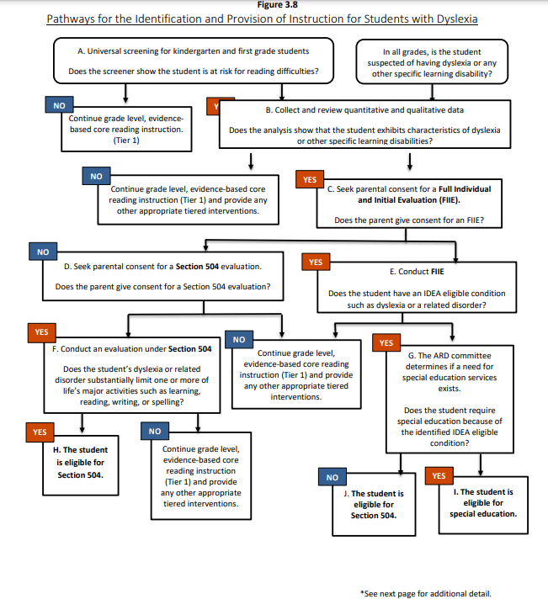
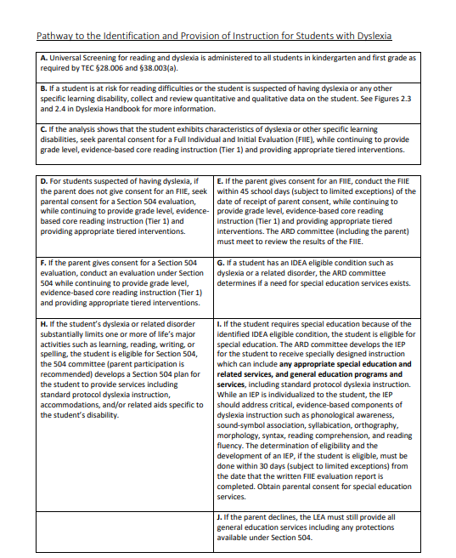

Identification of Students with Dyslexia:

In order to make an informed determination, the committee must include members who are knowledgeable about:
  - The student being assessed
  - The reading process
  - Dyslexia and related disorders
  - Dyslexia instruction
  - District or charter school, state, and federal guidelines for assessment
  - The assessments used
  - The meaning of the collected data

The committee will review all accumulated data to determine whether the student demonstrates a pattern of evidence for dyslexia. This data will include the following:
  - The observations of the teacher, district or charter school staff, and/or parent/guardian
  - Data gathered from the classroom (including student work and the results of classroom measures) and information found in the student’s cumulative folder (including the developmental and academic history of the student)
  - Data-based documentation of student progress during instruction/intervention
  - The results of administered assessments
  - Language Assessment Proficiency Committee (LPAC) documentation, when applicable
  - All other accumulated data regarding the development of the student’s learning and his/her educational needs

Committee Decision Points for Dyslexia Identification:
The pattern of evidence for the primary characteristics of dyslexia with unexpectedly low performance for the student’s age and educational level in some or all of the following areas:
  - Reading words in isolation
  - Decoding unfamiliar words accurately and automatically
  - Reading fluency for connected text (both rate and/or accuracy)
  - Spelling (an isolated difficulty in spelling would not be sufficient to identify dyslexia)

    - Based on the data, if the committee determines weaknesses are indicated in the listed academic skills, the committee will look next at the underlying cognitive processes for the difficulties seen in the student’s word reading and written spelling. These difficulties will typically be the result of a deficit in phonological or phonemic awareness and/or orthographic processing. Additionally, there is often a family history of similar difficulties.

The student may also demonstrate difficulties in other areas of cognitive processing, including one or more of the following:

      - Rapid naming
      - Orthographic processing
      - Phonological memory
      - Verbal working memory
      - Processing speed

    - If the student exhibits reading and written spelling difficulties and currently has appropriate phonological/phonemic processing, it is important to examine the student’s history to determine if there is evidence of previous difficulty with phonological/phoneme awareness. NOTE: Because previous effective instruction in phonological/phonemic awareness may remediate phonological awareness skills in isolation, average phonological awareness scores alone do not rule out dyslexia. Ongoing phonological processing deficits can be exhibited in word reading and/or written spelling.

    - If the committee determines the student exhibits weaknesses in reading and written spelling, the committee will then examine the student’s data to determine whether these difficulties are unexpected for the student in relation to the student’s other cognitive abilities (the ability to learn in the absence of print) AND unexpected in relation to the provision of effective classroom instruction.

Many students with dyslexia will have difficulty with the secondary characteristics of dyslexia, including reading comprehension and written composition.

The committee will also incorporate the following guidelines from TEC §38.003 and 19 TAC
§74.28:
  - The student has received conventional (appropriate) instruction
  - The student has an unexpected lack of appropriate academic progress (in the areas of reading and spelling)
  - The student has adequate intelligence (an average ability to learn in the absence of print or in other academic areas)
  - The student exhibits characteristics associated with dyslexia
  - The student’s lack of progress is not due to socio-cultural factors such as language differences, irregular attendance, or lack of experiential background.

Assessment of Special Education Students
If a student is already in special education but exhibits the characteristics of dyslexia or related disorders and is referred for assessment, assessment procedures for students under the Individuals with Disabilities Act (IDEA 2004) will be followed. Assessment data from prior special education assessments may be utilized, and/or additional assessment may be conducted

by personnel trained in assessment to evaluate students for dyslexia and related disorders. In this case, the ARD committee will make determinations for those students.

If the student with dyslexia is found eligible for special education in the area of reading, and the ARD committee determines the student’s instructional needs for reading are most appropriately met in a special education placement, the student’s Individualized Education Program (IEP) must include appropriate reading instruction. Appropriate reading instruction includes the components and delivery of dyslexia instruction listed in The Dyslexia Handbook ~ Revised 2014, Chapter III, “Instruction for Students with Dyslexia.”

Assessment of Students Identified Outside the District
Students identified as having dyslexia or related disorders from an outside source will be evaluated for eligibility in the district’s program. ISD may choose to accept the outside assessment, or may re-assess the student. In either situation, the committee (§504 or ARD) will review the identification status of a student enrolled in ISD, and the placement of the student in the dyslexia program(s).

Non-Identification
If the committee agrees that the student does not demonstrate characteristics of dyslexia at the time of assessment then an RTI plan may be considered in the areas of concern, as needed.

Instruction for Students with Dyslexia
Once it has been determined that a student has dyslexia, ISD shall provide an appropriate instructional program for the student as required in TEC §38.003:
The board of trustees of each school district shall provide for the treatment of any student determined to have dyslexia or a related disorder. http://www.statutes.legis.state.tx.us/Docs/ED/htm/ED.38.htm#38.003

The following procedures must be followed:
  - Instructional decisions for a student with dyslexia are made by a team that is knowledgeable about the student, the meaning of the evaluation information, and instructional components and delivery of instruction for students with dyslexia.
  - ISD shall purchase or develop a reading program for students with dyslexia and related disorders that is aligned with the descriptors found in this handbook. The descriptors include the components of phonemic awareness, sound-symbol association, syllabication, orthography, morphology, syntax, reading comprehension, and reading fluency. Instructional approaches include simultaneous, multisensory, systematic and cumulative, explicit, diagnostic teaching to automaticity, synthetic and analytic instruction (19 TAC §74.28). The components of instruction and instructional approaches are described in the next section of the ISD plan.
  - ISD must provide each identified student access at his/her campus to an instructional program that meets the requirements in 19 TAC §74.28(c) and to the services of a teacher trained in dyslexia and related disorders. The school district may,

with the approval of each student’s parents or guardians, offer additional services at a centralized location. Such centralized services shall not preclude each student from receiving services at his or her campus (19 TAC §74.28).
  - Parents/guardians of students eligible under §504 or IDEA must be informed of all services and options available to the student under that federal statute.
  - Teachers who provide the appropriate instruction for students with dyslexia must be trained in instructional strategies that utilize individualized, intensive, multisensory, phonetic methods and a variety of writing and spelling components specified in the next section of this plan. (19 TAC §74.28).
  - Teachers who provide the appropriate instruction for students with dyslexia must be trained in the professional development activities specified by ISD, and/or campus planning and decision making committee which shall include the instructional strategies indicated above (19 TAC §74.28).

ISD shall provide a parent education program for the parents/guardians of students with dyslexia and related disorders. The program should include the following:
  - Characteristics of dyslexia and related disorders
  - Information on assessment and diagnosis of dyslexia
  - Information on effective strategies for teaching students with dyslexia
  - Awareness of information on classroom modifications and especially of modifications allowed on standardized testing (19 TAC §74.28)

If the team suspects that the student has dyslexia or a related disorder, the team should consider the type of instruction that would best meet the student’s needs.

Standard Protocol Dyslexia Instruction
For the student who has not benefited from the research-based core reading instruction, the components of instruction will include additional focused intervention as appropriate for the reading needs of the student with dyslexia. Standard protocol dyslexia instruction provides evidence-based, multisensory structured literacy instruction for students with dyslexia. A standard protocol dyslexia instructional program must be explicit, systematic, and intentional in its approach. This instruction is designed for all students with dyslexia and will often take place in a small group setting. Standard protocol dyslexia instruction must be—
• evidence-based and effective for students with dyslexia;
• taught by an appropriately trained instructor; and
• implemented with fidelity.

Instructional decisions for a student with dyslexia must be made by a committee (Section 504 or ARD) that is knowledgeable about the instructional components and approaches for students with dyslexia. It is important to remember that while dyslexia instruction is most successful when provided as early as possible, older children with reading disabilities will also benefit from focused and intensive remedial instruction.

In accordance with 19 TAC §74.28(e), districts must purchase or develop an evidence-based reading program for students with dyslexia and related disorders that incorporates all the components of instruction and instructional approaches described in the sections below. As is the case with any instructional program, 40 differentiation that does not compromise the fidelity of a program may be necessary to address different learning styles and ability levels and to promote progress among students receiving dyslexia instruction. While districts and charter schools must implement an evidence-based instructional program for students with dyslexia that meets each of the components described in this chapter, standard protocol dyslexia instruction provided to students may focus on components of the program that best meet the student’s needs. For example, this may occur when a student with dyslexia who has participated in standard protocol dyslexia instruction in the past, but continues to need remediation in some, but not all of, the components (e.g. fluency, written expression).

Specially Designed Instruction
For students with dyslexia who have been determined eligible for and who are receiving special education services, specially designed instruction must also address the critical, evidence-based components described in this chapter. Specially designed instruction differs from standard protocol dyslexia instruction in that it offers a more individualized program specifically designed to meet a student’s unique needs. Note that participation in standard protocol dyslexia instruction must be considered for all students, including those receiving dyslexia instruction under the IDEA. Standard protocol dyslexia instruction could be part of the specially designed instruction and services provided to meet the student’s needs.

For students with dyslexia who have been determined eligible for and who are receiving special education services, specifically designed instruction must also address the critical,
evidence-based components described in this chapter. Specifically designed instruction differs from standard protocol dyslexia instruction in that it offers a more individualized program specifically designed to meet a student’s unique needs. Note that participation in standard protocol dyslexia instruction must be considered for all students, including those receiving dyslexia instruction under the IDEA. Standard protocol dyslexia instruction could be part of the specifically designed instruction and services provided to meet the student’s needs.

Instructional decisions for a student with dyslexia must be made by a committee that is knowledgeable about the instructional components and approaches for students with dyslexia. In accordance with 19 TAC §74.28(c), districts shall purchase or develop a reading program for students with dyslexia and related disorders that incorporates all of the following components of instruction and instructional approaches.

Critical, Evidence-Based Components of Dyslexia Instruction
- Phonological Awareness
- Sound-symbol Association
- Syllabication
- Orthography
- Morphology
- Syntax
- Reading Comprehension

Delivery of Dyslexia Instruction
- Simultaneous, multisensory (VAKT Instruction)
- Systematic and Cumulative Instruction
- Explicit instruction
- Diagnostic teaching to automaticity
- Synthetic instruction
- Analytic instruction

Both the teacher of dyslexia and the regular classroom teacher should provide multiple opportunities to support intervention and to strengthen these skills; therefore, responsibility for teaching reading and writing must be shared by classroom teachers, reading specialists, interventionists, and teachers of dyslexia programs.

Providers of Dyslexia Instruction

In order to provide effective intervention, school districts are encouraged to employ highly trained individuals to deliver dyslexia instruction. Teachers, such as reading specialists, master reading teachers, general education classroom teachers, or special education teachers, who

provide dyslexia intervention for students are not required to hold a specific license or certification. However, these educators must at a minimum have additional documented dyslexia training aligned to 19 TAC 74.28(c) and must deliver the instruction with fidelity. This includes training in critical, evidence-based components of dyslexia instruction such as phonological awareness, sound-symbol association, syllabication, orthography, morphology, syntax, reading comprehension, and reading fluency.

In addition, they must deliver multisensory instruction that simultaneously uses all learning pathways to the brain, is systematic and cumulative, is explicitly taught, uses diagnostics teaching to automaticity, and includes both analytic and synthetic approaches. A provider of dyslexia instruction does not have to be certified as a special educator when serving a student who also receives special education and related services if that provider is the most appropriate person to offer dyslexia instruction.

Dysgraphia

Difficulty with handwriting frequently occurs in children with dyslexia. When Texas passed dyslexia legislation, the co-existence of poor handwriting with dyslexia was one reason why dysgraphia was called a related disorder. Subsequently, dyslexia and dysgraphia have been found to have diverse co-morbidities, including phonological awareness (Döhla and Heim, 2016).
However, dyslexia and dysgraphia are now recognized to be distinct disorders that can exist concurrently or separately. They have different brain mechanisms and identifiable characteristics.

Dysgraphia is related to dyslexia as both are language-based disorders. In dyslexia, the impairment is with word-level skills (decoding, word identification, spelling). Dysgraphia is a written language disorder in serial production of strokes to form a handwritten letter. This involves not only motor skills but also language skills—finding, retrieving and producing letters, which is a subword-level language skill. The impaired handwriting may interfere with spelling and/or composing, but individuals with only dysgraphia do not have difficulty with reading (Berninger, Richards, & Abbott, 2015).

The characteristics of dysgraphia include the following:
- Variably shaped and poorly formed letters
- Excessive erasures and cross-outs
- Poor spacing between letters and words
- Letter and number reversals beyond early stages of writing
- Awkward, inconsistent pencil grip
- Heavy pressure and hand fatigue
- Slow writing and copying with legible or illegible handwriting (Andrews & Lombardino, 2014)

Additional consequences of dysgraphia may also include:
- Difficulty with unedited written spelling
- Low volume of written output as well as problems with other aspects of written expression

Dysgraphia is not:
- Evidence of a damaged motor nervous system
- Part of a developmental disability that has fine motor deficits (e.g., intellectual disability, autism, cerebral palsy)
- Secondary to a medical condition (e.g., meningitis, significant head trauma, brain trauma)
- Association with generalized developmental motor or coordination difficulties (Developmental Coordination Disorder)
- Impaired spelling or written expression with typical handwriting (legibility and rate) (Berninger, 2004)

Dysgraphia can be due to:
- Impaired feedback the brain is receiving from the fingers
- Weaknesses using visual processing to coordinate hand movement and organize the use of space
- Problems with motor planning and sequencing
- Difficulty with storage and retrieval of letter forms (Levine, 1999)

Despite the widespread beliefs that handwriting is purely a motor skill or that only multisensory methods are needed to teach handwriting, multiple language processes are also involved in handwriting. Handwriting draws on language by hand (letter production), language by ear (listening to letter names when writing dictated letters), language by mouth (saying letter names), and language by eye (viewing the letters to be copied or reviewing for accuracy the letters that are produced from memory) (Berninger & Wolf, 2016).

Procedures for Evaluation:

The process of identifying dysgraphia will follow Child Find procedures for conducting a full individual and initial evaluation (FIIE) under the IDEA. These procedural processes require coordination among the teacher, campus administrators, diagnosticians, and other professionals as appropriate when factors such as a student’s English language acquisition, previously identified disability, or other special needs are present.

The first step in the evaluation process, data gathering, should be an integral part of the district’s or charter school’s process for any student exhibiting learning difficulties. Documentation of the following characteristics of dysgraphia could be collected during the data gathering phase:

- Slow or labored written work
- Poor formation of letters
- Improper letter slant
- Poor pencil grip
- Inadequate pressure during handwriting (too hard or too soft)
- Excessive erasures
- Poor spacing between words

- Poor spacing inside words
- Inability to recall accurate orthographic patterns for words
- “b” and “d” reversals beyond developmentally appropriate time
- Inability to copy words accurately
- Inability of student to read what was previously written
- Overuse of short familiar words such as “big”
- Avoidance of written tasks
- Difficulty with visual-motor integrated sports or activities
While schools must follow federal and state guidelines, they must also develop procedures that address the needs of their student populations. Schools shall recommend evaluation for dysgraphia if the student demonstrates the following:

- Impaired or illegible handwriting that is unexpected for the student’s age/grade
- Impaired handwriting that interferes with spelling, written expression, or both that is unexpected for the student’s age/grade

- Data Gathering

Schools collect data on all students to ensure that instruction is appropriate and scientifically based. Essential components of comprehensive literacy instruction, including writing, are defined in Section 2221(b) of ESSA as explicit instruction in writing, including opportunities for children to write with clear purposes, with critical reasoning appropriate to the topic and purpose, and with specific instruction and feedback from instructional staff.

Any time from kindergarten through grade 12 a student continues to struggle with one or more components of writing, schools must collect additional information about the student. Schools should use previously collected as well as current information to evaluate the student’s academic progress and determine what actions are needed to ensure the student’s improved academic performance. The collection of various data, as indicated in Figure 5.1 below, will provide information regarding factors that may be contributing to or primarily to the student’s struggles with handwriting, spelling, and written expression.

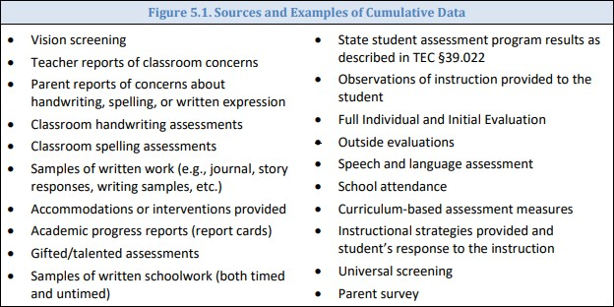

- Formal Evaluation

After data gathering, the next step in the process is formal evaluation. This is not a screening; rather, it is an individualized evaluation used to gather evaluation data. Formal evaluation includes both formal and informal data. All data will be used to determine whether the student demonstrates a pattern of evidence for dysgraphia. Information collected from the parents/guardians also provides valuable insight into the student’s early years of written language development. This history may help to explain why students come to the evaluation with many different strengths and weaknesses; therefore, findings from the formal evaluation will be different for each child. Professionals conducting evaluations for the identification of dysgraphia will need to look beyond scores on standardized assessments alone and examine the student’s classroom writing performance, educational history, and early language experiences to assist with determining handwriting, spelling, and written expression abilities and difficulties.

Notification and Permission
When formal evaluation is recommended, the school completes the evaluation process as outlined in IDEA. Procedural safeguards under the IDEA must be followed. For more information on procedural safeguards, see Appendix D, IDEA/Section 504 Side-by-Side Comparison, and TEA’s Parent Guide to the Admission, Review, and Dismissal Process (Parent’s Guide).

Tests and Other Evaluation Materials

Test instruments and other evaluation materials must meet the following criteria:

- Be used for the purpose for which the evaluation or measures are valid or reliable

- Include material tailored to assess specific areas of educational need and not merely materials that are designed to provide a single general intelligence quotient
- Be selected and administered to ensure that, when a test is given to a student with impaired sensory, manual, or speaking skills, the test results accurately reflect the student’s aptitude, achievement level, or whatever other factor the test purports to measure, rather than reflecting the student’s impaired sensory, manual, or speaking skills
- Be selected and administered in a manner that is not racially or culturally discriminatory
- Include multiple measures of a student’s writing abilities such as informal assessment information (e.g., anecdotal records, district universal screenings, progress monitoring data, criterion-referenced evaluations, samples of written work, classroom observations)
- Be administered by trained personnel and in conformance with the instructions provided by the producer of the evaluation materials
- Be provided and administered in the student’s native language or other mode of communication and in the form most likely to yield accurate information regarding what the child can do academically, developmentally, and functionally, unless it is clearly not feasible to provide or administer.

Domains to Assess:
Academic Skills
The school administers measures that are related to the student’s educational needs. Difficulties in the areas of letter formation, orthographic awareness, and general handwriting skills may be evident dependent on the student’s age and writing development. Additionally, many students with dysgraphia may have difficulty with spelling and written expression.

Cognitive Processes
The process of handwriting requires the student to rely on memory for letters or symbol sequences, also known as orthographic processing. Memory for letter patterns, letter sequences, and the letters in whole words may be selectively impaired or may coexist with phonological processing weaknesses. When spelling, a student must not only process both phonological and orthographic information, but also apply their knowledge of morphology and syntax (Berninger & Wolf, 2009).

Figure 5.2 Areas for Evaluation of Dysgraphia
Academic Skills
- Letter formation
- Handwriting Word/sentence dictation (timed and untimed)
- Copying of Text
- Written expression
- Spelling
- Written Fluency (both accuracy and fluency)
Cognitive Processes

- Memory for letter or symbols sequences (orthographic processing)
Possible Additional Area
- Phonological awareness
- Phonological memory
- Working memory
- Letter retrieval
- Letter matching

Procedures for Identification:

To make an informed determination the ARD committee must include members who are knowledgeable about the following:

- Student being assessed
- Evaluation instruments being used
- Interpretation of the data being collected

Additionally, the committee members should have knowledge regarding
- the handwriting process;
- dysgraphia and related disorders;
- dysgraphia instruction, and;
- district or charter school, state, and federal guidelines for evaluation.

Review and Interpretation of Data and Evaluation:

To appropriately understand evaluation data, the ARD committee must interpret test results in light of the student’s educational history, linguistic background, environmental or socioeconomic factors, and any other pertinent factors that affect learning.

A determination must first be made regarding whether a student’s difficulties in the areas of writing and spelling reflect a pattern of evidence for the primary characteristics of dysgraphia with unexpectedly low performance for the student’s age and educational level in some or all of the following areas:

- Handwriting
- Writing fluency (accuracy and rate)
- Written Expression
- Spelling

Based on the above information and guidelines, should the ARD committee determine that the student exhibits weakness in writing and spelling, the committee will then examine the student’s

data to determine whether these difficulties are unexpected in relation to the student’s other abilities, sociocultural factors, language differences, irregular attendance, or lack of appropriate and effective instruction. For example, the student may exhibit strengths in areas such as reading comprehension, listening comprehension, oral verbal ability, or math reasoning yet still have difficulty with writing and spelling. Therefore, it is not one single indicator, but a preponderance of informal and formal data that provide the committee with evidence for whether these difficulties are unexpected.

Dysgraphia Identification:
If the student’s difficulties are unexpected in relation to other abilities, the ARD committee must then determine if the student has dysgraphia. The list of questions in Figure 5.3 below must be considered when making a determination regarding dysgraphia.

Figure 5.3 Questions to Determine the Identification of Dysgraphia
- Do the data show the following characteristics and consequences of dysgraphia?
  - Illegible and/or inefficient handwriting with variably shaped and poorly formed letters
  - Difficulty with unedited written spelling
  - Low volume of written output as well as problems with other aspects of written expression
- Do these difficulties (typically) result from a deficit in graphmotor function (hand movements used for writing) and/or storing and retrieving orthographic codes (letter forms)?
- Are these difficulties unexpected for the student’s age in relation to the student's other abilities, and the provision of effective classroom instruction.

Once dysgraphia has been identified, a determination must be made regarding the most appropriate way to serve the student.

The ARD committee will determine whether the student who has dysgraphia is eligible under IDEA as a student with a specific learning disability. The student is eligible for services under IDEA if he/she has dysgraphia and, because of the dysgraphia needs special education services. The October 23, 2015 letter from the Office of Special Education and Rehabilitative Services (OSERS) (Dear Colleague: Dyslexia Guidance) states that dyslexia, dyscalculia, and dysgraphia are conditions that could qualify a child as a child with a specific learning disability under IDEA. The letter further states that there is nothing in the IDEA that would prohibit the use of the terms

dyslexia, dyscalculia, and dysgraphia in IDEA evaluation, eligibility determinations, or IEP documents. For more information, please visit: https://www2.ed.gov/policy/speced/guid/idea/memosdcltrs/guidance-on-dyslexia-10-2015.pdf.

If the student with dysgraphia is found eligible for special education, the student’s IEP must include appropriate writing instruction, which might include instruction from a related services provider.

If the student is identified with dysgraphia but is not considered a student with a disability under IDEA (because the student does not need specifically designed instruction), then the student may receive appropriate accommodations and services under Section 504. Students are protected under Section 504 if the physical or mental impairment (dysgraphia) substantially limits one or more major life activities, such as the specific activity of writing. Additionally, the Section 504 committee, in determining whether a student has a disability that substantially limits the student in a major life activity (writing) must not consider the ameliorating effects of any mitigating measure that student is using.

Revision of the Section 504 plan will occur as the student’s response to instruction and to the use of accommodations, if any, is observed. Changes in instruction and /or accommodations must be supported by current data (e.g. classroom performance and dyslexia program monitoring).

Instruction for Students with Dysgraphia:

“. . . Done right, early handwriting instruction improves students’ writing. Not just its legibility, but its quantity and quality.” (p. 49)
—S. Graham, Want to Improve Children’s Writing? Don’t Neglect Their Handwriting, American Educator, 2010

Graham and his colleagues describe two reasons for teaching handwriting effectively. The first reason is what they call the Presentation Effect. Research demonstrates that, in general, a reader’s evaluation of a composition’s quality is influenced by how neatly it is written (Graham, Harris, & Hebert, 2011). The second reason that educational scientists give for teaching handwriting effectively is called the Writer Effect. Research demonstrates that handwriting difficulties interfere with other writing processes such as expression of ideas and organization. In fact, a 2016 meta-analysis showed that handwriting instruction improved students’ writing fluency, quantity, and quality. The findings of this research report were dramatic, showing moderate effects on writing fluency and very large effects on the number of words students wrote and the quality of their compositions (Santangelo & Graham, 2016).

Handwriting interferes with other writing processes or consumes an inordinate amount of cognitive resources, at least until handwriting becomes automatic and fluent … Handwriting-instructed students made greater gains than peers who did not receive handwriting instruction in the quality of their writing, how much they wrote, and writing fluency. (p. 226)

—Santangelo & Graham, A Comprehensive Meta-Analysis of Handwriting Instruction, 2016

Supporting Students Struggling with Handwriting:

Between 10% and 30% of students struggle with handwriting. Early difficulties in this area are significantly correlated with poorer performance on composition tasks. The following are research-based elements of effective handwriting instruction. These elements, which apply to both manuscript and cursive handwriting, may not necessarily apply to an entire class but instead may be used to support instructional methods delivered in small groups with students whose penmanship is illegible or dysfluent.

- Show students how to hold a pencil.
- Model efficient and legible letter formation.
- Provide multiple opportunities for students to practice effective letter formation.
- Use scaffolds, such as letters with numbered arrows showing the order and direction of strokes.
- Have students practice writing letters from memory.
- Provide handwriting fluency practice to build students’ automaticity.
- Practice handwriting in short sessions.

Some students who struggle with handwriting may actually have dysgraphia. Dysgraphia may occur alone, or with dyslexia. An assessment for dysgraphia, as it relates to dyslexia, is important in order to determine whether children need additional explicit, systematic instruction in handwriting only; handwriting and spelling; or handwriting, spelling, and written expression along with word reading and decoding (IDA, 2012).

Texas Education Code §38.003(b) states, “In accordance with the program approved by the State Board of Education, the board of trustees of each school district shall provide for the treatment of any student determined to have dyslexia or a related disorder.”

While it is important for students with dysgraphia to receive the research-based elements of handwriting, spelling, and written language instruction as part of the core curriculum, for those students who require additional supports and services for dysgraphia, instructional decisions must be made by a committee (either Section 504 or ARD) that is knowledgeable about the instructional elements and delivery of instruction that is consistent with research-based practice.

Handwriting:

The research-based elements for effective instruction of handwriting as stated above for all students are the same for students with dysgraphia. However, the intensity, frequency, and delivery of instruction may need to be adjusted to meet specific student need as determined by

the Section 504 or ARD committee. Figure 5.4 below provides a hierarchy of instruction for handwriting as a reference to best practice:
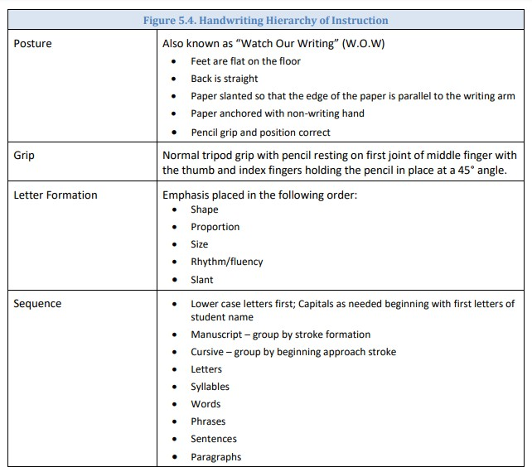

Spelling:

Handwriting supports spelling, a complex process of translating a phoneme (spoken sound) to the corresponding grapheme (orthographic representation) in order to generate written text to express an idea. Orthography is the written spelling patterns and rules in a given language.
Students must be taught the regularity and irregularity of the orthographic patterns of a language in an explicit and systematic manner. The instruction should be integrated with phonology and sound-symbol knowledge. Because spelling is meaning driven and draws upon the phonological, orthographic, and morphological aspects of words, students will benefit from systematic, explicit instruction based on the following guiding principles:
- Phoneme-grapheme correspondence
- Letter order and sequence patterns, or orthographic conventions: o syllable types

o orthographic rules
o irregular words
  - Position of a phoneme or grapheme in a word
  - Meaning (morphology) and part of speech
  - Language of origin (Moats, 2005)

Writing:

A potential secondary consequence of dysgraphia is difficulty with students expressing themselves in written text. This difficulty may be attributed to deficits in handwriting, spelling, language processing, or the integration of each of those skills. In Chapter IV of this handbook, Moats and Dakin (2008) are quoted as stating:

The ability to compose and transcribe conventional English with accuracy, fluency, and clarity of expression is known as basic writing skills. Writing is dependent on many language skills and processes and is often even more problematic for children than reading. Writing is a language discipline with many component skills that must be directly taught. Because writing demands using different skills at the same time, such as generating language, spelling, handwriting, and using capitalization and punctuation, it puts a significant demand on working memory and attention. Thus, a student may demonstrate mastery of these individual skills, but when asked to integrate them all at once, mastery of an individual skill, such as handwriting, often deteriorates. To write on demand, a student has to have mastered, to the point of being automatic, each skill involved (p. 55).

Students with written expression difficulties because of dysgraphia would benefit from being taught explicit strategies for composing including planning, generating, reviewing/evaluating, and revising different genre including narrative, informational, compare and contrast, and persuasive compositions (IDA, 2012).

Delivery of Intervention:

The way the content is delivered should be consistent with the principles of effective intervention for students with dysgraphia including the following:
- Simultaneous, multisensory (VAKT) — “Teaching is done using all learning pathways in the brain (visual, auditory, kinesthetic-tactile) simultaneously in order to enhance memory and learning” (Birsh, 2018, p. 19). “Children are actively engaged in learning language concepts and other information, often by using their hands, arms, mouths, eyes, and whole bodies while learning” (Moats & Dakin, 2008, p. 58).
- Systematic and cumulative — “Multisensory language instruction requires that the organization of material follow order of the language. The sequence must begin with the easiest concepts and most basic elements and progress methodically to more difficult material. Each step must also be

based on [elements] already learned. Concepts taught must be systematically reviewed to strengthen memory” (Birsh, 2018, p. 19).
- Explicit instruction — “Explicit instruction is explained and demonstrated by the teacher one language and print concept at a time, rather than left to discovery through incidental encounters with information. Poor readers do not learn that print represents speech simply from exposure to books or print” (Moats & Dakin, 2008, p. 58). Explicit Instruction is “an approach that involves direct instruction: The teacher demonstrates the task and provides guided practice with immediate corrective feedback before the student attempts the task independently” (Mather & Wendling, 2012, p. 326).
- Diagnostic teaching to automaticity — “The teacher must be adept at prescriptive or individualized teaching. The teaching plan is based on careful and [continual] assessment of the individual's needs. The content presented must be mastered to the degree of automaticity” (Birsh, 2018, p. 27). “This teacher knowledge is essential for guiding the content and emphasis of instruction for the individual student” (Moats & Dakin, 2008, p. 58). “When a reading skill becomes automatic (direct access without conscious awareness), it is performed quickly in an efficient manner” (Berninger & Wolf, 2009, p. 70).

F: Instructional Accommodations for Students with Dyslexia

Instructional Accommodations for Students with Disabilities

Students with dyslexia who receive dyslexia instruction that contains the components described in this chapter will be better equipped to meet the demands of grade-level or course instruction. In addition to dyslexia instruction, accommodations provide the student with dyslexia effective and equitable access to grade-level or course instruction in the general education classroom.
Accommodations are not one size fits all; rather, the impact of dyslexia on each individual student determines the necessary accommodation. Listed below are examples of reasonable classroom accommodations:

- Copies of notes (e.g., teacher- or peer-provided)
- Note-taking assistance
- Additional time on class assignments and tests
- Reduced/shortened assignments (e.g., chunking assignments into manageable units, fewer items given on a classroom test or homework assignment without eliminating concepts, or student planner to assist with assignments)
- Alternative test location that provides a quiet environment and reduces distractions
- Priority seating assignment
- Oral reading of directions or written material
- Word banks
- Audiobooks
- Text to speech
- Speech to text
- Electronic spellers

- Electronic dictionaries
- Formula charts
- Adaptive learning tools and features in software programs
Accommodations are changes to materials, actions, or techniques, including the use of technology, that enable students with disabilities to participate meaningfully in grade-level or course instruction. The use of accommodations occurs primarily during classroom instruction as educators use various instructional strategies to meet the needs of each student. A student may need an accommodation only temporarily while learning a new skill, or a student might require the accommodation throughout the school year and over several years including beyond graduation.

Decisions about which accommodations to use are very individualized and should be made for each student by that student’s ARD or Section 504 committee, as appropriate. Students can, and should, play a significant role in choosing and using accommodations. Students need to know what accommodations are possible, and then, based on knowledge of their personal strengths and limitations, they select and try accommodations that might be useful for them. The more input students have in their own accommodation choices, the more likely it is that they will use and benefit from the accommodations.

When making decisions about accommodations, instruction is always the foremost priority. Not all accommodations used in the classroom are allowed during a state assessment. However, an educator’s ability to meet the individual needs of a student with dyslexia or provide support for the use of an accommodation should not be limited by whether an accommodation is allowable on a state assessment

Instructional Accommodations for the Student with Dysgraphia

By receiving instruction based on the elements described in this chapter, a student with dysgraphia is better equipped to meet the demands of grade-level or course instruction. In addition to targeted instruction, accommodations provide the student with dysgraphia effective and equitable access to grade-level or course instruction in the general education classroom.
Accommodations are not a one size fits all; rather, the impact of dysgraphia on each individual student determines the accommodation. When considering accommodations for the student with dysgraphia, consider the following:
- The rate of producing written work
- The volume of the work to be produced
- The complexity of the writing task
- The tools used to produce the written product
- The format of the product (Texas Scottish Rite Hospital for Children, 2018, p. 5).

Listed below are examples of reasonable classroom accommodations for a student with dysgraphia based on the above considerations:
- Allow more time for written tasks including note taking, copying, and tests
- Reduce the length requirements of written assignments

- Provide copies of notes or assign a note taking buddy to assist with filling in missing information
- Allow the student to audio record important assignments and/or take oral tests
- Assist student with developing logical steps to complete a writing assignment instead of all at once
- Allow the use of technology (e.g., speech to text software, etc.)
- Allow the student to use cursive or manuscript, whichever is most legible and efficient
- Allow the student to use graph paper for math, or to turn lined paper sideways, to help with lining up columns of numbers
- Offer an alternative to a written project such as an oral report, dramatic presentation, or visual media project

Accommodations are changes to materials, actions, or techniques, including the use of technology, that enable students with disabilities to participate meaningfully in grade-level or course instruction. The use of accommodations occurs primarily during classroom instruction as educators use various instructional strategies to meet the needs of each student. A student may need an accommodation only temporarily while learning a new skill, or a student might require the accommodation throughout the school year or over several years including beyond graduation.

Decisions about which accommodations to use are very individualized and should be made for each student by that student’s ARD or Section 504 committee, as appropriate. Students can, and should, play a significant role in choosing and using accommodations. Students need to know what accommodations are possible, and then, based on knowledge of their personal strengths and limitations, they select and try accommodations that might be useful for them. The more input students have in their own accommodation choices, the more likely it is that they will use and benefit from the accommodations.

When making decisions about accommodations, instruction is always the foremost priority. Not all accommodations used in the classroom are allowed during a state assessment. However, an educator’s ability to meet the individual needs of a student with dysgraphia or provide support for the use of an accommodation should not be limited by whether an accommodation is allowable on a state assessment.

In order to make accommodation decisions for students, educators should have knowledge of the Texas Essential Knowledge and Skills (TEKS) and how a student performs in relation to them.
Educators should also collect and analyze data pertaining to the use and effectiveness of accommodations (e.g., assignment/test scores with and without the accommodation, observational reports from parents and teachers) so that informed educational decisions can be made for each student. By analyzing data, an educator can determine if the accommodation becomes inappropriate or unnecessary over time due to the student’s changing needs. Likewise, data can confirm for the educator that the student still struggles in certain areas and should continue to use the accommodation.

For more information about accommodations, see At a Glance: Classroom Accommodations for Dysgraphia, available at
https://www.understood.org/en/school-learning/partnering-with-childs-school/instructionalstrateg ies/at-a-glance-classroom-accommodations-for-dysgraphia

Technology Tools

There are many technology resources to assist a student with dysgraphia. The Technology Integration for Students with Dyslexia online tool (TEC §38.0031) is a resource developed to support school districts and charter schools in making instructional decisions regarding technology that benefit students with dyslexia and related disorders. For more information and to view this source, visit https://www.region10.org/programs/dyslexia/techplan/.

Timeline

When a referral for dyslexia assessment is made, ISD will ensure the evaluation procedure is followed in a reasonable amount of time. If assumes responsibility for evaluation,
Texas law establishes that a full individual and initial evaluation
(FIE) must be completed within 45-school days from the time a district or charter school receives consent. Section 504, however, does not require specific timelines. Therefore, ISD will adhere to the timelines Texas has established for special education evaluations through TEC
§29.004(a).

Student Monitoring and Dyslexia Program Exit Criteria
Upon successful completion of ISDs dyslexia program(s), the 504 or ARD committee will determine exit and monitoring criteria.

Monitoring may include, but is not limited to the collection/evaluation of:
  - Progress reports
  - Report cards
  - State assessment data
  - Teacher reports/checklists
  - Parent reports/checklists
  - Counselor reports
  - Other program reports

  - Additional assessment data

Students qualifying for dyslexia services that are identified as §504 or special education will follow monitoring/re-evaluation requirements outlined in federal law.

Contacts for Dyslexia and Related Disorders

It is our honor and privilege to work with your children! If there is anything we can help you with, please let us know at the numbers below.

Location | Name | Phone Number

