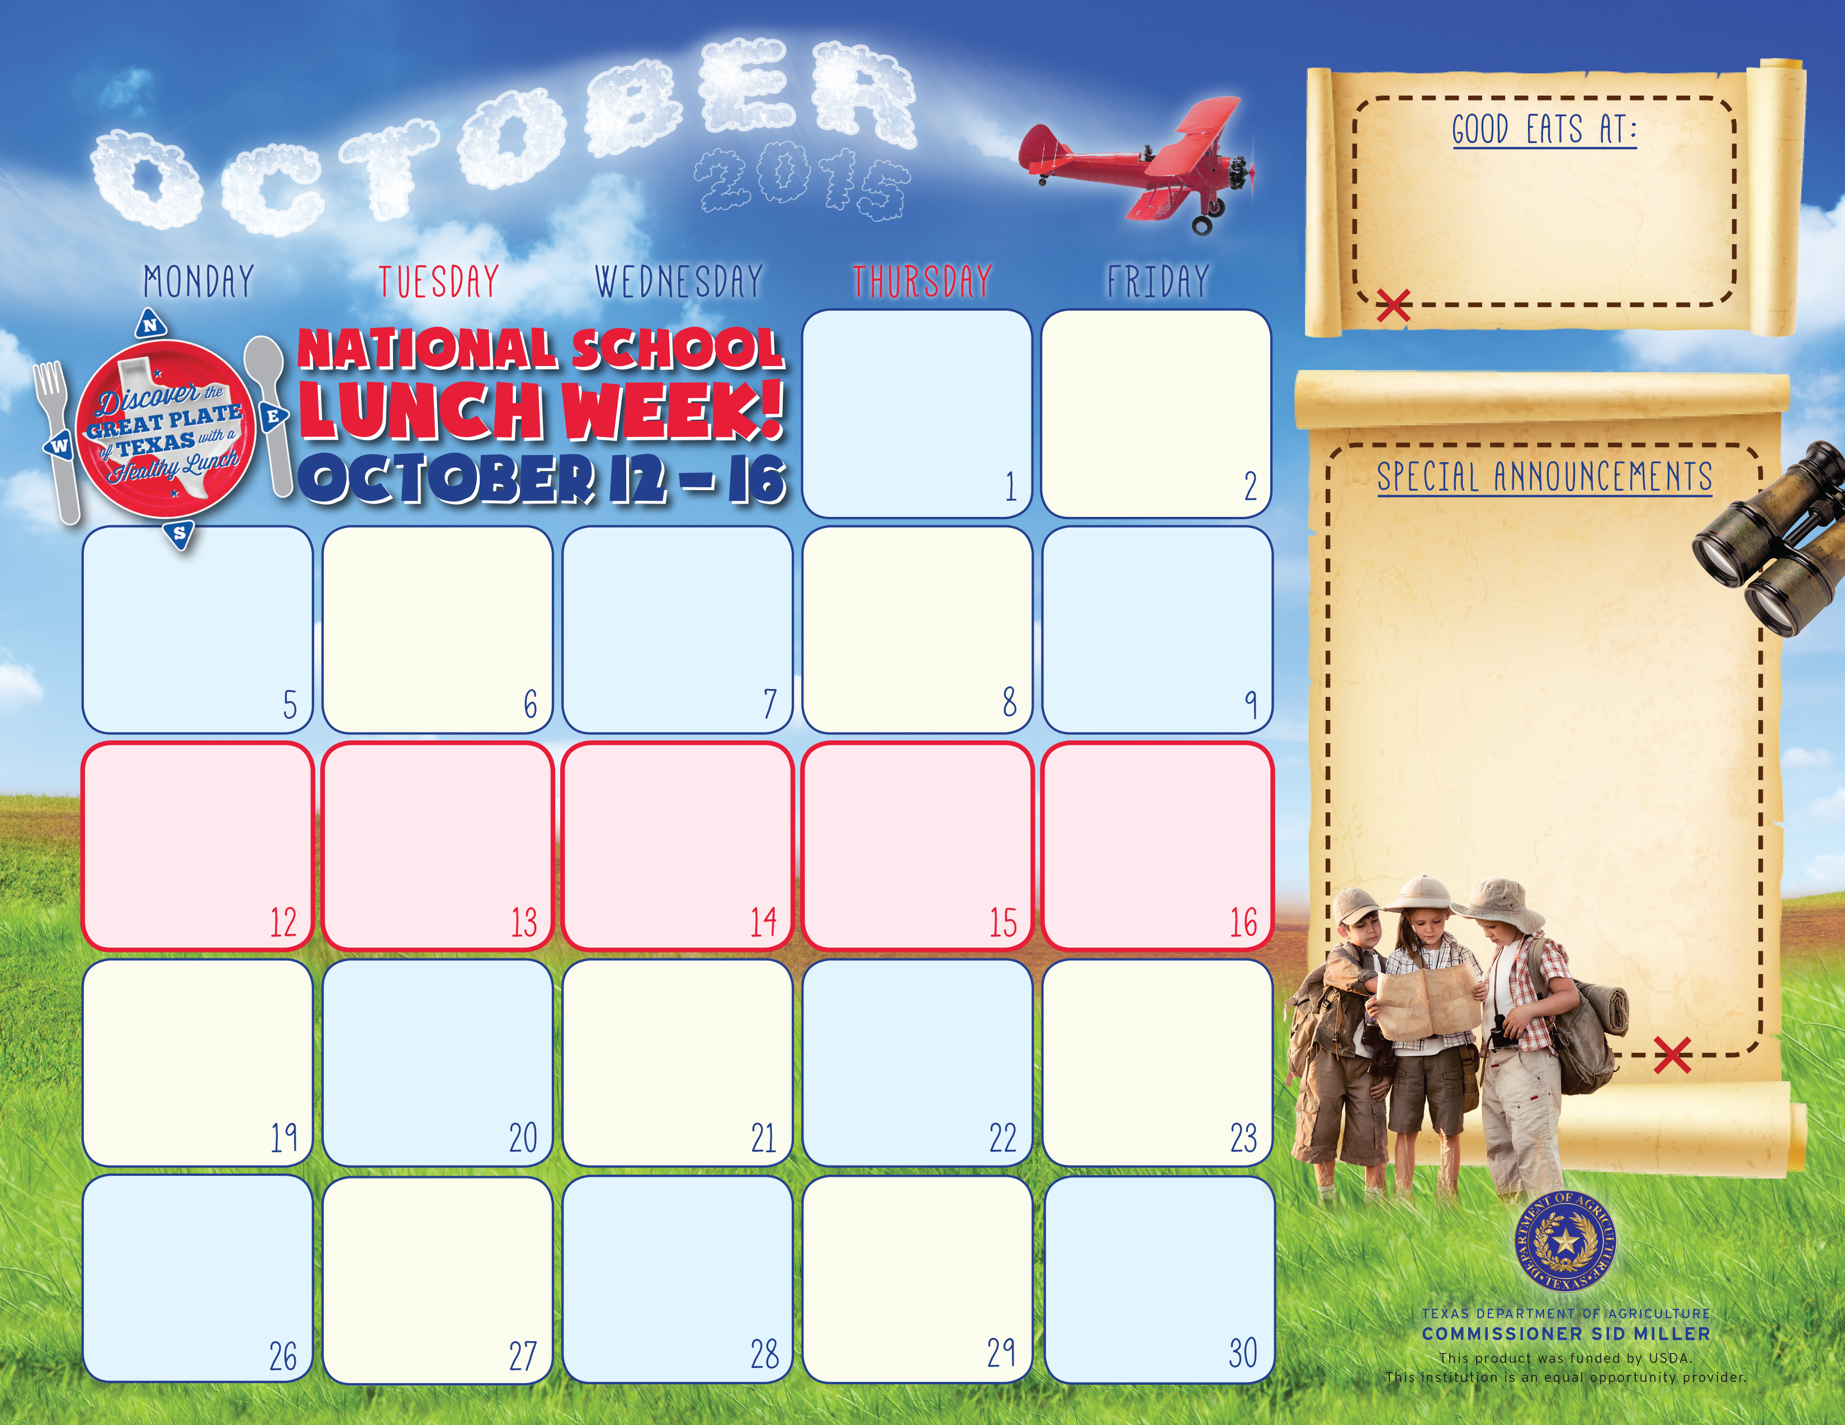

Fish Strips
Texas Toast
Coleslaw
Pinto Beans
Orange Smiles
Milk Variety

.
Pizza Choice
Garden Salad
Carrots w/Ranch
Mixed Fruit
Milk Variety
Chili Cheese Combo
W /Cornbread
Fresh Veggie Cup
Banana & Strawberries
Choc. /Vanilla Pudding
Milk Variety

Fiesta Taco Bowl
Spanish Rice
Black Beans, Corn
Tomato Cup
Pineapple Tidbits
Milk Variety

Chicken Nuggets
Mac & Cheese
Green Beans
Garden Salad
Apple Slices
Milk Variety

Milk Variety

Cheese Enchilada
Spanish Rice
Charro Beans
Garden Saladn
Cinnaman Apples
Milk Variety

K-12
Adult Breakfast $2.50
Lunch –
K -12 $2.35
Adults $3.00

Corn Dog
Oven Fries
Baby Carrots
Sliced Peaches
Crispy Cereal Treat.
Milk Variety

Meat & Cheese Tostadas , Salsa
Spanish Rice
Garden Salad
Refried Beans
Applesauce
Milk Variety

Chicken Spaghetti
Breadsticks
Garden Salad
Vegetable Medley
Apple Slices
Milk Variety

Frito Pie
Baby Carrots
Mexicali Corn
Orange Smiles
Cookie
Milk Variety

Chicken Strips
Mashed Potatoes w/Gravy, Roll,
Green Beans
Strawberry Cup
Milk Variety

Cheese Burger
Hamburger Garnish
Zesty Cucumbers
Potato Fries
Sliced Peaches
Milk Variety

Grilled Cheese Sandwich
Vegetable Soup
Tomato Cup
Garden Salad
Sliced Pears
Sherbet Cup
Milk Variety

Stuffed Baked Potato
Hot Roll,
Broccoli,
Baked Beans
Apple-Pineapple D’lite
Milk Variety

Salisbury Steak
Brown Gravy
Roasted Potatoes
Garden salad
Fruited Gelatin
Milk Variety

Beef & Bean Burrito
Seasoned Corn
Salsa
Fresh Veggie Cup
Mandarin Oranges
Milk Variety

Hot Dog
Corn Chips
Baby Carrots w/Ranch
Crunch Broccoli Salad
Fresh Grapes
Cookie
Milk Variety

Chicken Fajitas
Salsa
Garden Salad
Veggie Cup
Fresh Fruit Choice
Milk Variety

Zephyr School

Zephyr School

Asian Bowl
Egg Roll
Brown Rice
Baby carrots
Steamed Broccoli
Chilled Pineapple
Milk Variety

Tex-Mex Stack
Spanish Rice
Refried Beans
Salsa
Tomato Cup
Hot Cinnamon Apples
Milk Variety

Cheese Burger.
Lettuce & Tomatoes
Oven Fries
Western Beans
Diced Pears
Milk Variety

Pizza Choice
Green Beans
Garden Salad
Apple Slices
Milk Variety



