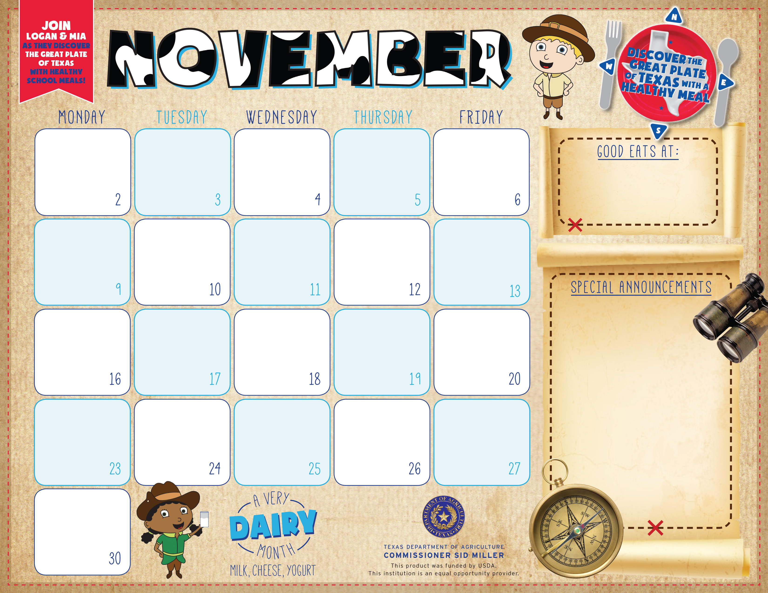

Teriyaki Beef Sand.
Potato Chips
Broccoli Bites
Garden Salad
Orange smiles
Milk Variety

Chicken Nuggets
Oven Roasted Fries
Cucumber Dippers
Fresh Fruit Choice
Cookie
Milk Variety

Spicy Thai Chicken
Egg Roll, Brown Rice,
Tomato-Cucumber Cup,
Steamed Broccoli ,
Snowball Salad
Milk Variety

Chicken Alfredo
Breadstick
Garden Salad ,
Carrot Coins
Apple Slices
Cookie
Milk Variety

Fish Strips
Texas Toast
Coleslaw
Pinto Beans
Orange Smiles
Milk Variety

Bulldog Chicken Bowl
Gravy, Green Beans,
Apple / Pineapple Dlite
Hot Roll
Milk Variety

Breakfast Free
K-12
Adult Breakfast $2.50

Lunch –
K -12 $2.35
Adults $3.00

Pizza Choice
Garden Salad
Carrots w/Ranch
Mixed Fruit
Milk Variety

Chili Cheese Combo
W /Cornbread
Fresh Veggie Cup
Banana & Strawberries
Choc. /Vanilla Pudding
Milk Variety

Fiesta Taco Bowl
Spanish Rice
Black Beans, Corn
Tomato Cup
Pineapple Tidbits
Milk Variety

Chicken Nuggets
Mac & Cheese
Green Beans
Garden Salad
Apple Slices
Milk Variety

Chicken Fried Steak
Gravy
Baked Potato
Glazed Carrots
Strawberries&
Bananas, Roll
Milk Variety
Corn Dog
Oven Fries
Baby Carrots
Sliced Peaches
Crispy Cereal Treat.
Milk Variety

Sub Sandwich
Potato Chips
Broccoli Bites
Garden Salad
Orange smiles
Milk Variety

No School

No School
Happy
Thanksgiving

Chicken Strips
Mashed Potatoes w/Gravy, Roll,
Green Beans
Strawberry Cup
Milk Variety

No School
Beef & Bean Burrito
Seasoned Corn
Salsa
Fresh Veggie Cup
Mandarin Oranges
Milk Variety

Zephyr School

Enchiladas
Spanish Rice Mexicali Corn
Charro Beans
Cinn. Applesauce
Milk Variety

Chicken Flatbread
Garden Salad
Tuscan Vegetables
Sliced Peaches
Choc. Or Vanilla Pudding
Milk Variety

Steak Fingers
Gravy
Baked Potato
Glazed Carrots
Strawberries&
Bananas, Roll
Milk Variety



