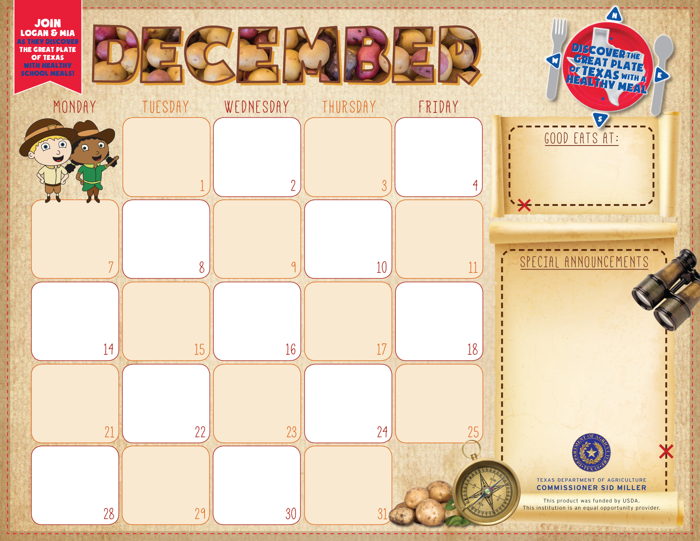

Grilled Cheese Sandwich, Soup,
Tomato Cup,
Garden Salad
Sliced Pears
Sherbet Cup
Milk Variety

Hot Dog
Corn Chips
Baby Carrots w/Ranch
Crunch Broccoli Salad
Fresh Grapes
Cookie
Milk Variety

Chicken Flatbread
Garden Salad
Tuscan Vegetables
Sliced Peaches
Choc. Or Vanilla Pudding
Milk Variety

Enchiladas
Spanish Rice Mexicali Corn
Charro Beans
Cinn. Applesauce
Milk Variety

Teriyaki Beef Sand.
Potato Chips
Broccoli Bites
Garden Salad
Orange smiles
Milk Variety

Steak Fingers
Gravy
Baked Potato
Glazed Carrots
Strawberries&
Bananas, Roll
Milk Variety

Breakfast Free
K-12
Adult Breakfast $2.50

Lunch –
K -12 $2.35
Adults $3.00

Chicken Nuggets
Oven Roasted Fries
Cucumber Dippers
Fresh Fruit Choice
Cookie
Milk Variety

Tex- Mex Stack
Spanish Rice
Refried Beans
Tomato Cup
Fruit Choice , Salsa
Milk Variety

Glazed Ham
Mashed Potatoes,
Brocoli & Rice
Garden Salad
Fruit Choice
Hot Roll
Milk Variety

Pizza Choice
Garden Salad
Carrots w/Ranch
Mixed Fruit
Milk Variety

Bulldog Chicken Bowl
Gravy, Green Beans,
Apple / Pineapple Dlite
Hot Roll
Milk Variety

Sub Sandwich
Potato Chips
Broccoli Bites
Garden Salad
Orange smiles
Milk Variety

No School

No School

No School

No School

Merry Christmas

No School

Zephyr School

No School

No School

No School

Stuffed Baked Potato
Hot Roll,
Broccoli,
Baked Beans
Apple-Pineapple D’lite
Milk Variety

Salisbury Steak
Brown Gravy
Roasted Potatoes
Garden Salad
Fruited Gelatin
Milk Variety


